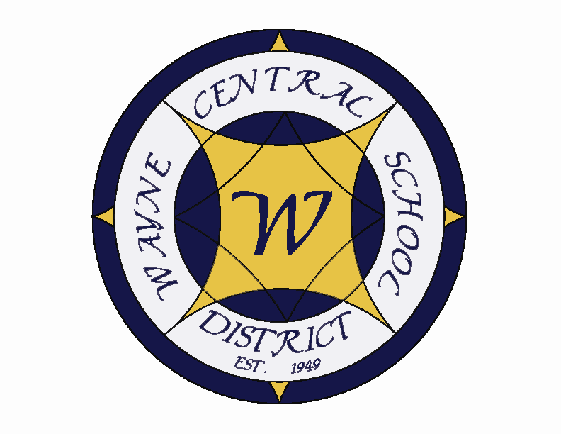
Letter to the Board

Michael Havens
Superintendent of Schools
Phone: 315-524-1001 Fax: 315-524-1049 mhavens@wayne.k12.ny.us

May 30, 2008

“You cannot escape the responsibility of tomorrow by evading it today. “
- - Abraham Lincoln, 16th President of the United States

Board Agenda:

1. Start Time: Please note that our meeting begins at 6:00 instead of the normal 7:00.

2. Textbook Adoption: Our 7th grade science teachers are presenting the new textbook for adoption. We have enclosed materials for your review. Unlike the previous adoption, there should be no concerns. We have always adopted textbooks on the night presented. Some of you have suggested we wait a meeting. I leave that decision to you.

3. Internship: Attached is the proposed internship for Scott Freischlag. You can see that I have set him up with multiple mentors for the year. I believe it is very comprehensive and will well prepare him for an administrative position. There is no additional cost to the district for this internship.

4. Student Representative: The student representative for this meeting is Chris Emery. Chris is a Freshman student council member and this is his second time serving as a student representative to the board.

4. Board Action: Of note on the personnel action is the appointment of our new wrestling coach. Ron is a Wayne graduate, currently teaching at Brighton and has been assisting that last few years. We have CSE action for approval. The consent agenda contains the April Treasurer’s report, a gift of funds from the MS PTO for the purchase of smart boards, a health contract with Penfield CSD, and Award Technology and Art supplies bid. As in the past few years, I am turning back ten days of vacation for reimbursement.

5. Policy: We have policy for first reading and single reading for board review.

Board Letter:

- Congratulations to Mrs. Lyke: Congratulations to Joyce who was reelected as vice president of four county. Also congratulations to Rick Johnson and Mark Wyse you were awarded certificates for there years of service to the Wayne Board of Education.

- Special Olympics: Mr. Blankenberg and I attended the Special Olympics held today in Canandaigua. Things went very well though I think they were better organized when we ran them (I could be a little prejudicial)

- High School Undergraduate Awards: We held our undergraduate awards assembly this week. It was one of the best organized in recent history. Congratulations to Board members Scott Griswold and Susan Newman whose daughters were honored.

- Building Project: We received the updated cost figures from LeChase in preparation for our Albany trip. Based on these numbers, our local share for the new building has risen to 12 million dollars. We hope to have completed our Albany trip by the June 19th Board meeting so we can present some options to you.

- Reminder: Following this Thursday’s meeting we will be retiring to Lori Smith’s house to honor the retirement of Mark and Rick. Spouses are encouraged to attend. We also ask that new Board members Dom and Jackie join us for both the meeting and the celebration.

- Board Workshop: As you recall, we cancelled the May 22 Board workshop because there were a number of Board members absent. The workshop has been rescheduled for our June 19th meeting. We ask that all Board members be sure to attend. The tentative date for Administrative/Board retreat is June 23rd . This will be an all day program hosted off site. Please let Lori know ASAP, if you have not done so already, if you can/cannot attend (this includes Jackie and Dom). Backup dates are June 26th and July 8th. Please let Lori know about your availability on those dates also (524-1001). Thanks.

- Transportation: The transportation department put together a nice informational sheet for kindergarten screening which helps explain a few of the initial questions and concerns most new parents might encounter. It hard to believe this is the class of 2021.

- Katie’s Closet: The Junior Class is holding a Prom Dress collection. This began in honor of the Fairport Teen(s) girls who were killed in a car crash a couple of years ago. This is happening this weekend at the high school in case anyone has a closet they need to clean out.

- Corporate Challenge: Congratulations to several staff members including Heather Melnick (coordinator), Kevin Shoemaker and Kim Cox who ran in the JP Morgan Corporate Challenge representing Wayne Central School District this week. I am very proud of our participants and the fact that “Rochester has the best “per capita” participation rate in the worldwide Series. One of every 19.3 city residents (based on a U.S. census figure of 215,093) take part in this event. For comparison sake, New York City 's per capita number is 232.65.”

- Upcoming Events:
5/30 – Traditional Memorial Day Parade (OE to American Legion Post) – 6:30 p.m.
6/3 – HS Chorus Concert @ PAC – 7:00 p.m.
6/5 – Board of Education Meeting @ DO – 7:00 p.m.
6/6 – FE 5th Grade Banquet

11. Attachments
a. Jason Carter Letter
b. Academic Thanks Letter (HS, MS, Elementary)
c. Transportation newsletter
d. Wayne’s World
e. Katie’s Closet

Wayne Central School District

Office of the Superintendent of Schools

P.O. Box 155
6200 Ontario Center Road
Ontario Center, NY 14520
315-524-1001
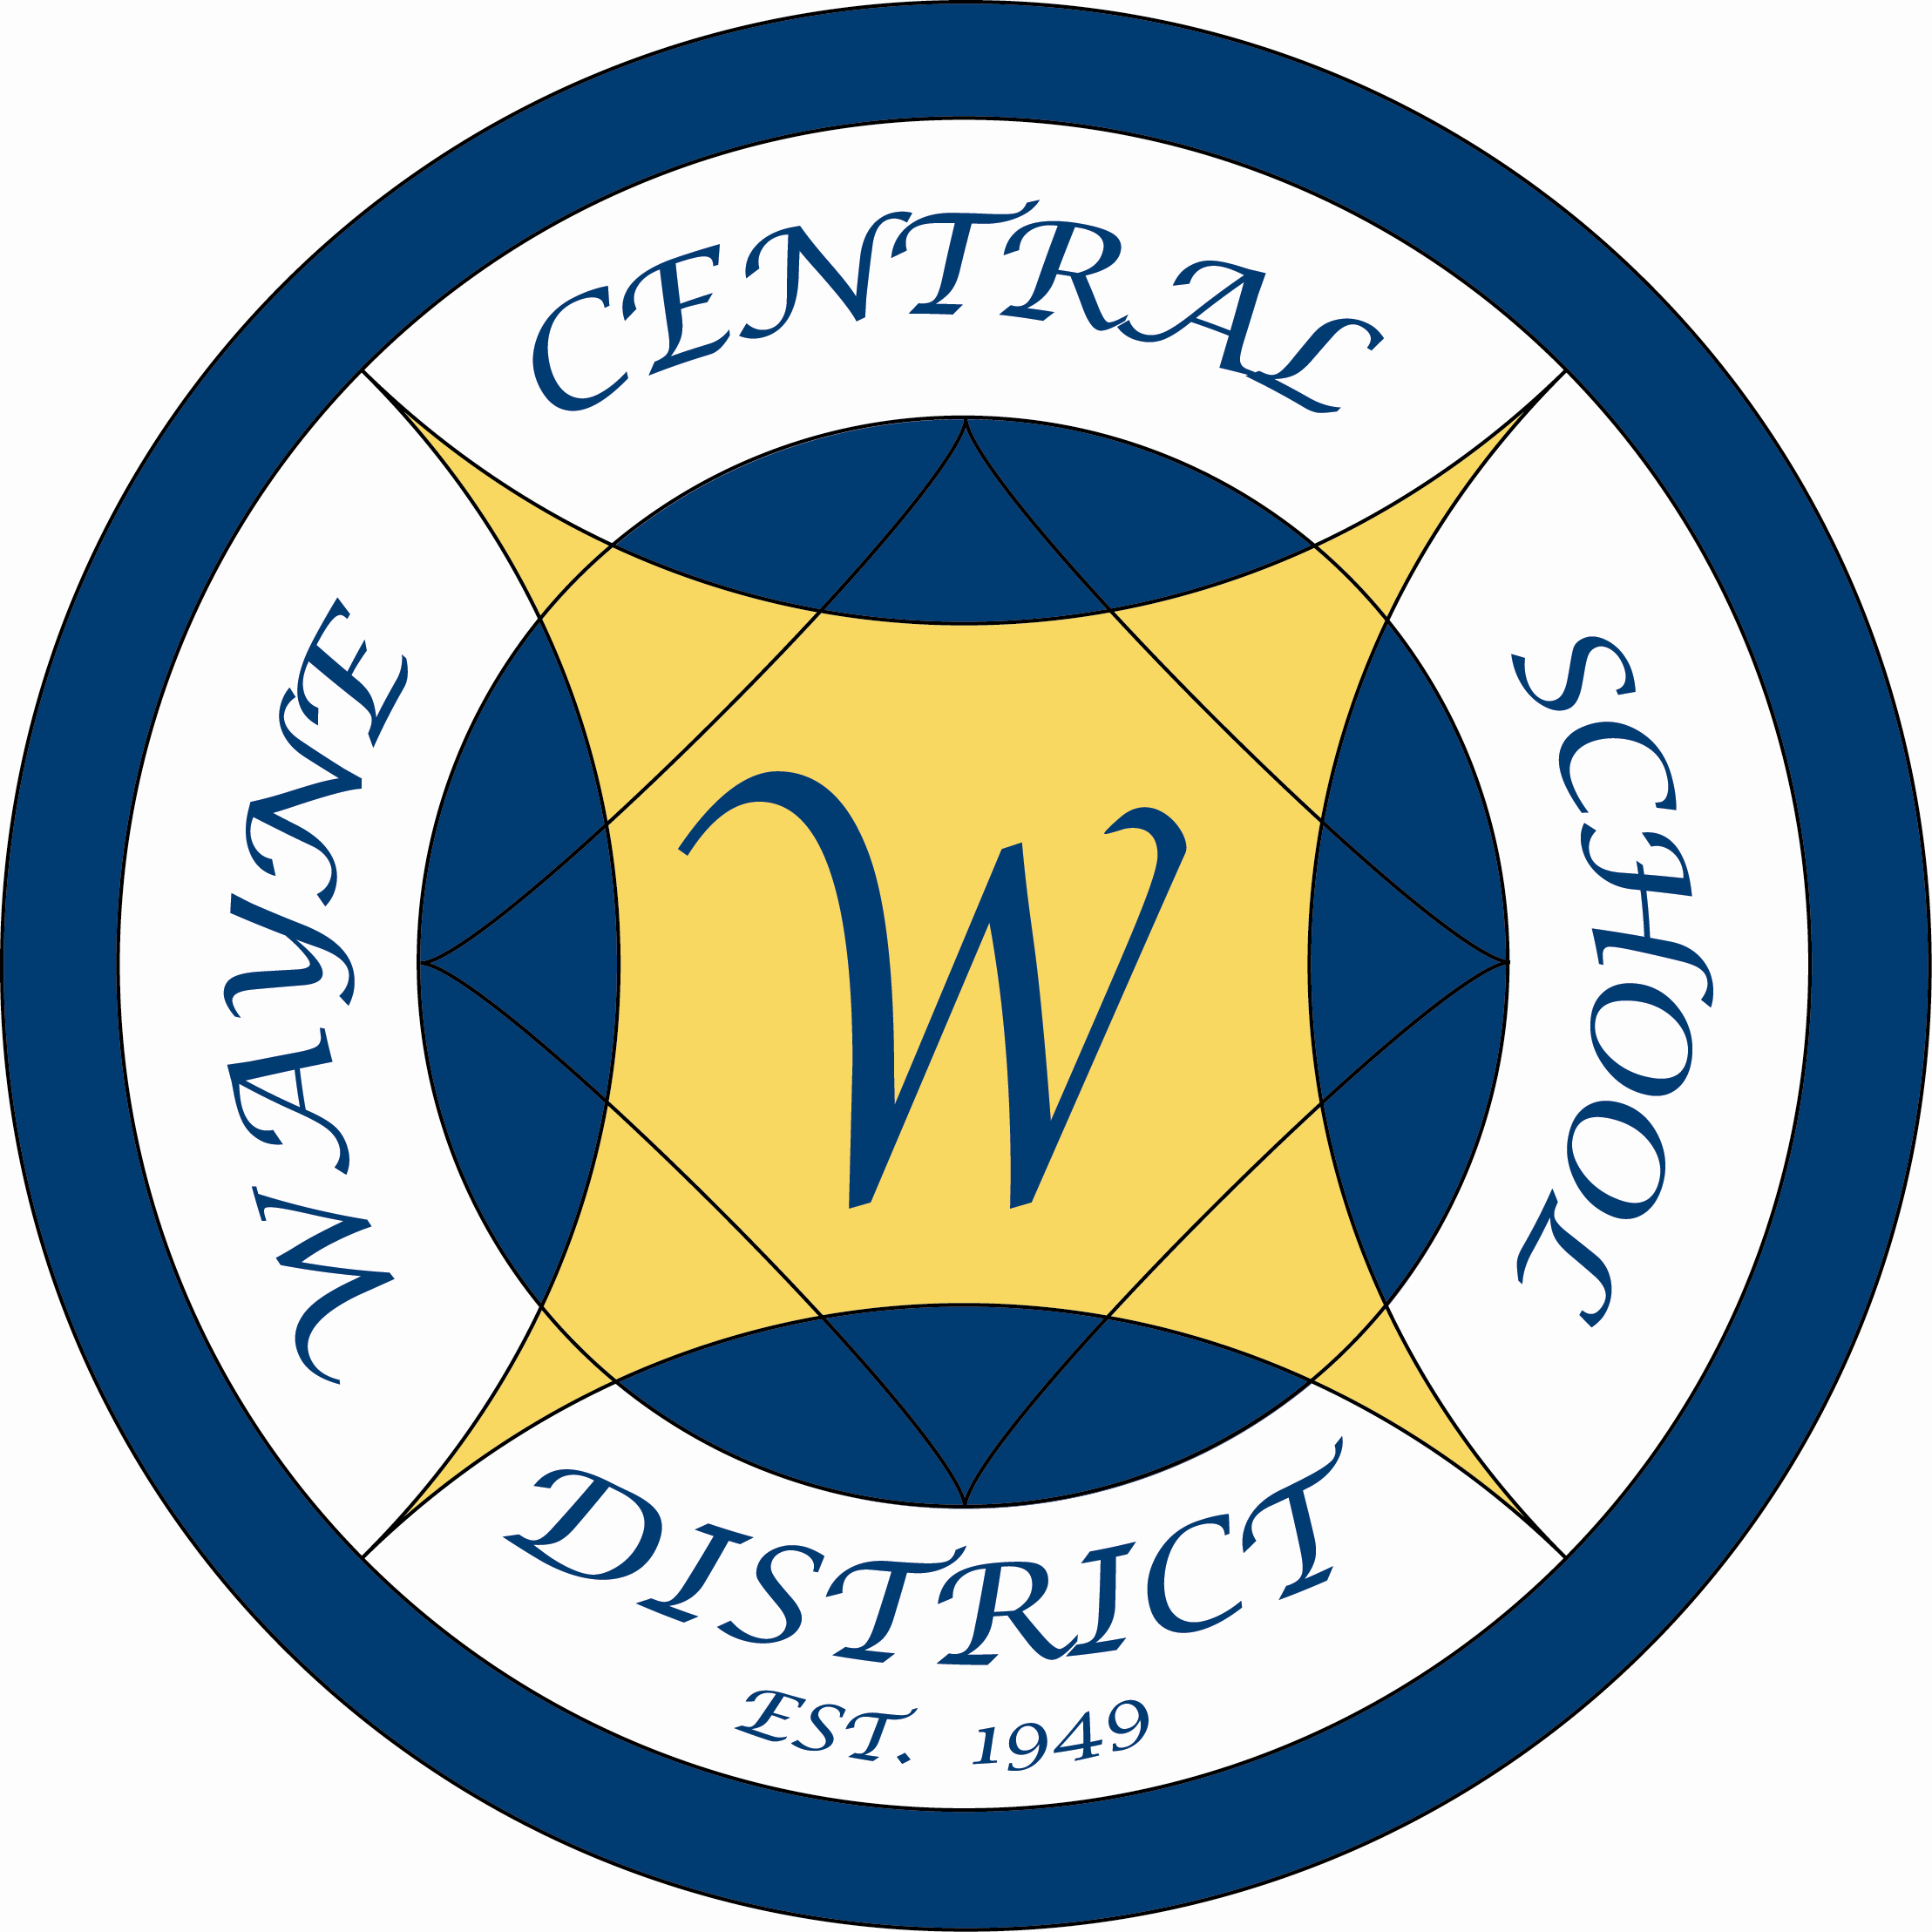

May 27, 2008

Jason Carter
Wayne Teachers’ Association

Dear Jason

On behalf of myself and the Board of Education of the Wayne Central School District, I would like to express our appreciation to the Wayne Teachers’ Association for your support of our recent budget vote.

The endorsement from the teachers of our district is a very powerful and meaningful statement for our community to hear, which underscores a belief in the overall quality of the educational programs, the facilities, and the direction our district is headed. We are all here for the greater good of the students within our walls.

Please share our appreciation to the entire WTA membership for your signs, mailings, and your commitment to our district.

Sincerely,

Michael Havens
Superintendent of Schools

/les
xc: Board of Education

“Students First – Excellence For All”

Wayne Central School District

Office of the Superintendent of Schools

P.O. Box 155
6200 Ontario Center Road
Ontario Center, NY 14520
315-524-1001

May 27, 2008

All Staff
Freewill Elementary School

Dear Staff,

At our last board meeting Assistant Superintendent Kim Cox presented the academic results of the third quarter marking period. On behalf of myself and the Board of Education of the Wayne Central School District, I would like to congratulate each and every member of the Freewill Elementary staff for the third quarter academic successes within our district. The achievement levels are among the highest we have seen at Wayne.

The Wayne Central High School and Middle School academic reports also show excellent academic growth and achievement. While we celebrate the successes of our middle and high school students individually, the board and administration realize that what they have accomplished is the culmination of years of study and learning. A learning process that began from the day these young students entered kindergarten and has continued in every grade and in every classroom from that day forward. So, it is on occasions like this, when our students make particularly noteworthy academic strides, that I am so pleased to acknowledge the hard work and efforts of all of our staff in helping our students achieve great things.

I thank you again, for everything you do for our students.

Sincerely,

Michael Havens
Superintendent of Schools

/les
xc: Board of Education

“Students First – Excellence For All”

Wayne Central School District

Office of the Superintendent of Schools

P.O. Box 155
6200 Ontario Center Road
Ontario Center, NY 14520
315-524-1001

May 27, 2008

All Staff
Wayne Middle School

Dear Staff,

At our last board meeting Assistant Superintendent Kim Cox presented the academic results of the third quarter marking period. On behalf of myself and the Board of Education of the Wayne Central School District, I would like to congratulate each and every member of the Wayne Middle School staff for the third quarter academic successes within our district. The achievement levels are among the highest we have seen at Wayne.

The Wayne Central High School reports also show excellent academic growth and achievement. While we celebrate the successes of our middle and high school students individually, the board and administration realize that what they have accomplished is the culmination of years of study and learning. So, it is on occasions like this, when our students make particularly noteworthy academic strides, that I am so pleased to acknowledge the hard work and efforts of all of our staff in helping our students achieve great things.

I thank you again, for everything you do for our students everyday.

Sincerely,

Michael Havens
Superintendent of Schools

/les
xc: Board of Education

“Students First – Excellence For All”

Wayne Central School District

Office of the Superintendent of Schools

P.O. Box 155
6200 Ontario Center Road
Ontario Center, NY 14520
315-524-1001

May 27, 2008

All Staff
Wayne High School

Dear Staff,

At our last board meeting Assistant Superintendent Kim Cox presented the academic results of the third quarter marking period. On behalf of myself and the Board of Education of the Wayne Central School District, I would like to congratulate each and every member of the Wayne High School staff for the third quarter academic successes within our district. The achievement levels are among the highest we have seen at Wayne.

It takes an effective and coordinated effort by all staff to raise our students self motivation, confidence and commitment. You have collectively found a way to make that happen here at the high school. While we celebrate the successes of our high school students individually, the board and administration realize that what they have accomplished is the culmination of years of study and learning. So, it is on occasions like this, when our students make particularly noteworthy academic strides, that I am so pleased to acknowledge the hard work and efforts of all of our staff in helping our students achieve great things.

I thank you again, for everything you do for our students everyday.

Sincerely,

Michael Havens
Superintendent of Schools

/les
` xc: Board of Education

“Students First – Excellence For All”



